- Lovable code gets updated in the link https://github.com/RPUNIBO/action-ready
- 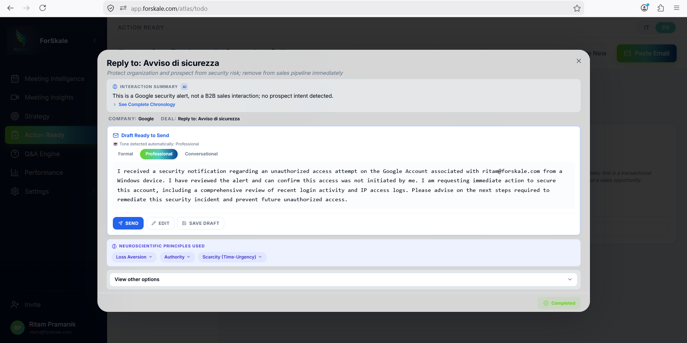After opening a card in the Draft Ready to Send section, we want to implement the possibility of more option other than edit seand and save draft, but have Gmail-Style Rich Text Editor Implementation
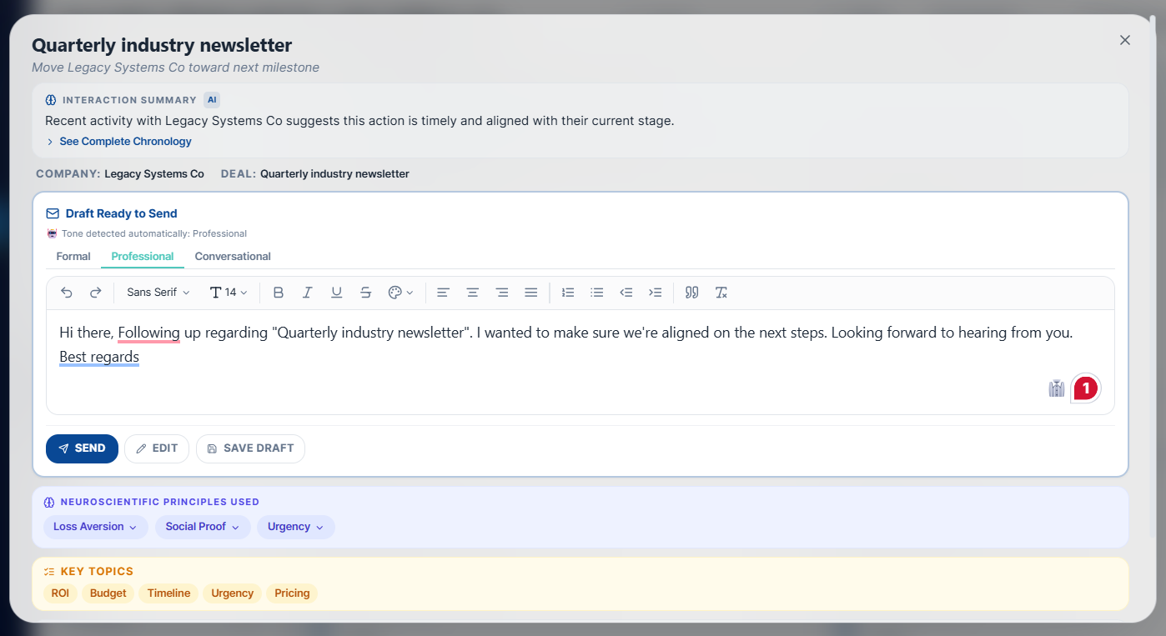
Replaced the plain text draft display with a Gmail-style rich text editor featuring a full toolbar (bold, italic, underline, font family/size, color picker, alignment, lists, indent, quote, undo/redo) — all integrated into the Draft Ready To Send section of the Action Ready modal.

- Implementing both the tone detection logic fix and file attachment functionality.
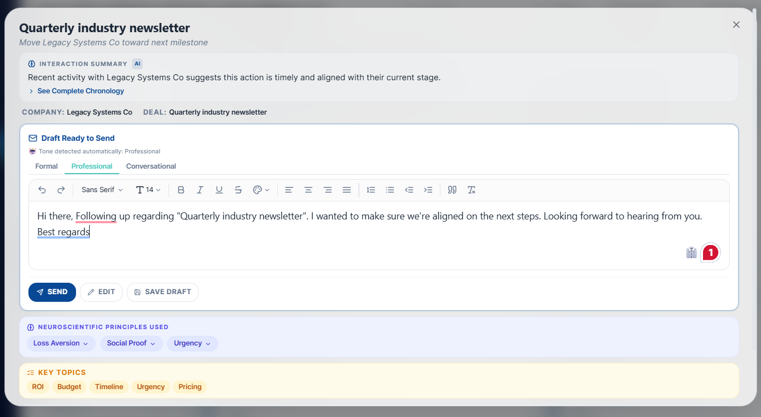
Current Implementation changes the Tone Logic on the basis of selection, which is not correct. And there is no file attach option in the Gmail Style Editor
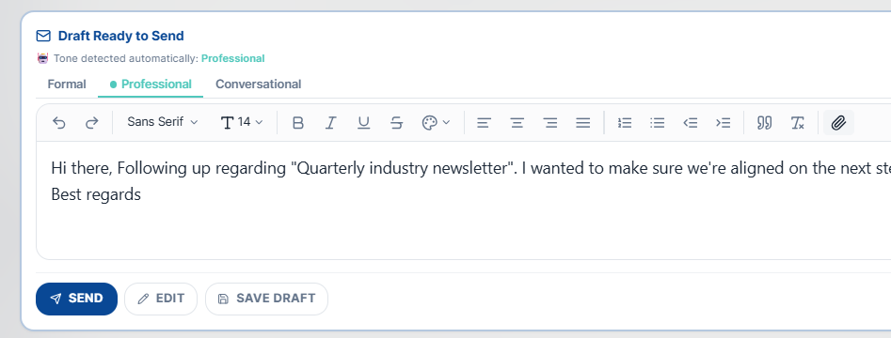
Implemented both features: ToneSelector with separated AI-detected vs user-selected tone (with accent dot indicator), and file attachments in the Gmail rich text editor (Paperclip button, file chips with type icons and remove).
Files created: src/components/action-ready/ToneSelector.tsx, updated src/components/editor/GmailRichTextEditor.tsx
Files modified: src/components/atlas/action-card/ActionCardExpanded.tsx, src/components/atlas/ActionCard.tsx, src/components/atlas/action-card/types.ts

- Removed the Edit button and its unused Pencil import as clicking the text box already enables editing.
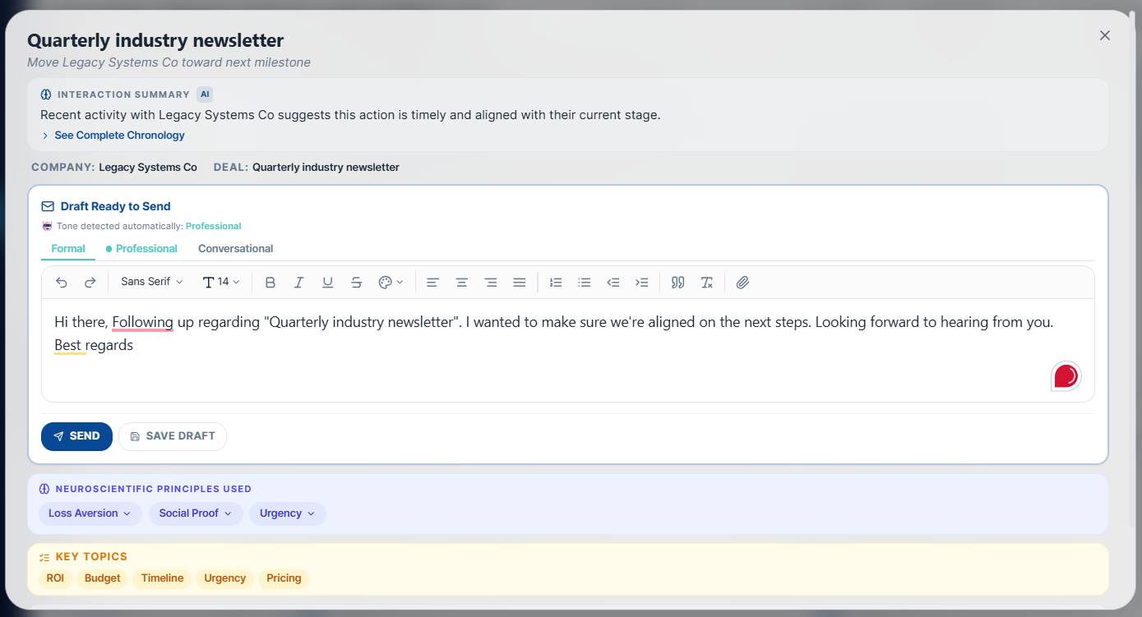

- On scrolling the card, the title and Objective of the expanded card should stay fixed
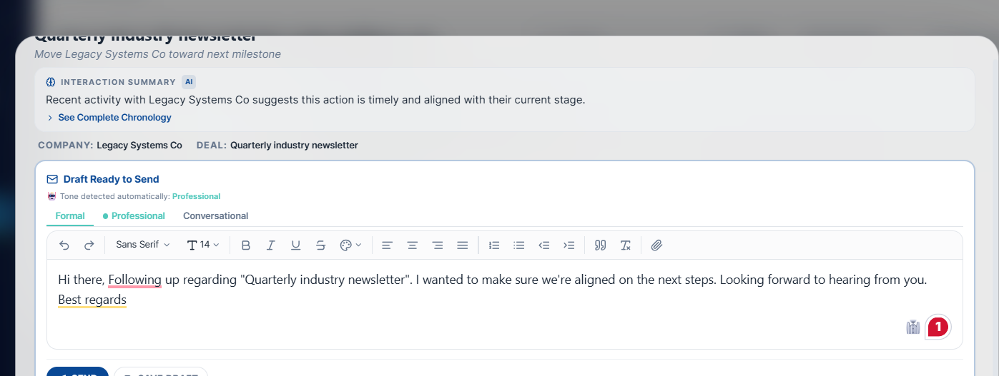
Implemented sticky header for the Action Ready modal — the title and objective now stay pinned at the top while the body content scrolls beneath with a semi-transparent backdrop blur effect.
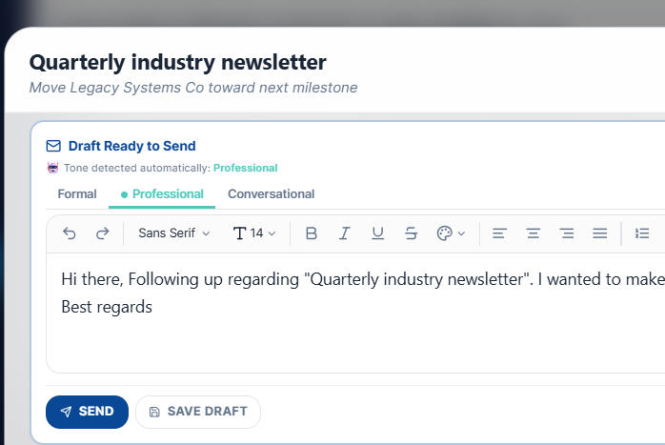

- possibility of selecting font from list looks stuck. 12 fonts, each rendered in its own typeface so users see a live preview. Tone Tabs hide while editing. Unsaved Changes Popup.
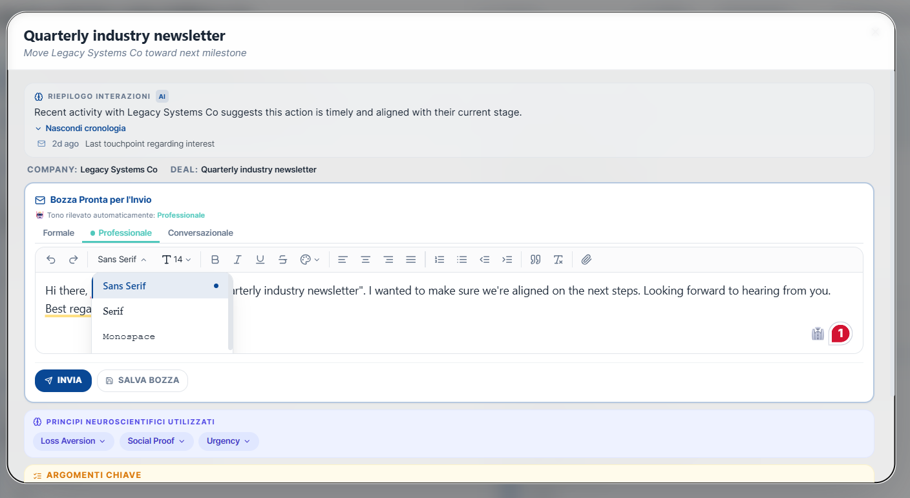
Enhanced Font Dropdown — 12 fonts rendered in their own typeface, gradient fade scroll hint, active indicator with left accent border, smooth slide-in animation
Tone Tabs Hide While Editing — tabs swap to a compact ToneBadge on editor focus, restore on blur/save
Unsaved Changes Popup — frosted glass dialog appears when clicking outside with dirty edits, with Save Draft and Discard options + amber dot indicator on the Save Draft button

